Unit: 6 |  |  | TRADITIONS AND LANGUAGE
School |  |  | School-gumnasium named after M. Gabdullin
Teacher’s name: |  |  | Baltabaeva A.S.
Date: |  |  | 06.02.2024
Grade 9 a | present: |  |  |  | absent:
Theme of the lesson: Emphasizing
Learning objective (s) that this lesson is contributing to |  |  |  | 9.6.3.1 - use a variety of compound adjectives and adjectives as participles and a variety of comparative structures to indicate degree on a range of familiar general and curricular topics;  9.1.9.1 - use imagination to express thoughts, ideas, experiences and feelings
Lesson objectives |  |  |  | All learners will be able to:
Most learners will be able to:
distinguish the use of words so/such, do/did
use these words in speech
 |  |  |  | Some learners will be able to:
Plan
Planned timings |  | Teacher’s activities |  |  |  | Pupil’s activities | Mark | Resources
Greeting |  | Greet students; students respond to greeting and take their places. Hello, boys and girls! How are you?
Warm up, check homework  7 min. |  | game «Snowball friendship»  The teacher gives an example of what to write on a piece of paper  I have a car  I like swimming  I can cook a pie  all the answers are collected into one snowball.  Students take turns opening the snowball, reading it and saying who wrote it.  These are page numbers from the book Battle Hymn of the Tiger Mother. The teacher opens a pre-prepared page and reads the task on this page. The student who has the number of this page performs the task |  |  |  | Students write 3 sentences about themselves on a piece of paper  The student who has the number of this page performs the task | Individual evaluation | Paper  Paper and  
Middle  32 min. |  | Ask students to complete sentences 1–2 before finding the sentences in the text to check their answers. Ask students to work with a partner to complete the rule. Check answers in open class. Refer to the examples in Exercise 1 to clarify and add further examples if necessary.  Rule  1 such 2 so  2 If you’re short on time, you can set this exercise for  homework.  Students fill the gaps and complete the sentences with their own ideas. Divide the class into pairs for students to compare answers. Listen to some  examples in open class as feedback.  do and did for emphasis  3 To promote noticing, ask students to fill the gaps, and then find the sentences in the text to check their answers. Before they look at the rule, you could ask them to consider the effect of do and did in the example sentences.  1 Books closed. As a lead-in, ask students: Which words can we use to make sentences more emphatic?  Elicit answers in open class and write so/such/do/ did on the board. If students have difficulty, write the following on the board and point out where the words should go in each sentence.  He is (such) a nice man.  I am (so) tired.  I (do) like swimming in the sea.  I (did) do my homework.  Books open. Students work with a partner to complete the exercise. During whole-class feedback, say the sentences for students to repeat and check  pronunciation. Encourage them to be emphatic!  2 In pairs or small groups, students talk about the person they’ve chosen. Monitor to encourage students to use emphatic structures where possible.  During feedback, ask for volunteers to share their descriptions with the class.  3 game «Pizza» |  |  |  | Answers  1 so 2 such  Answers  1 do 2 did  Answers  1 did like 2 do think we shouldn’t  Answers  1 He’s such a good father.  2 She gets on so well with children.  3 She’s so patient.  4 My dad did try his best.  5 My parents did make some mistakes.  6 She’s so soft on her children.  7 He’s such a strict father.  8 Parents do get it wrong sometimes.  children translate sentences using new grammar | Individual evaluation | https://www.  google.com/  search?q=so  +such+%  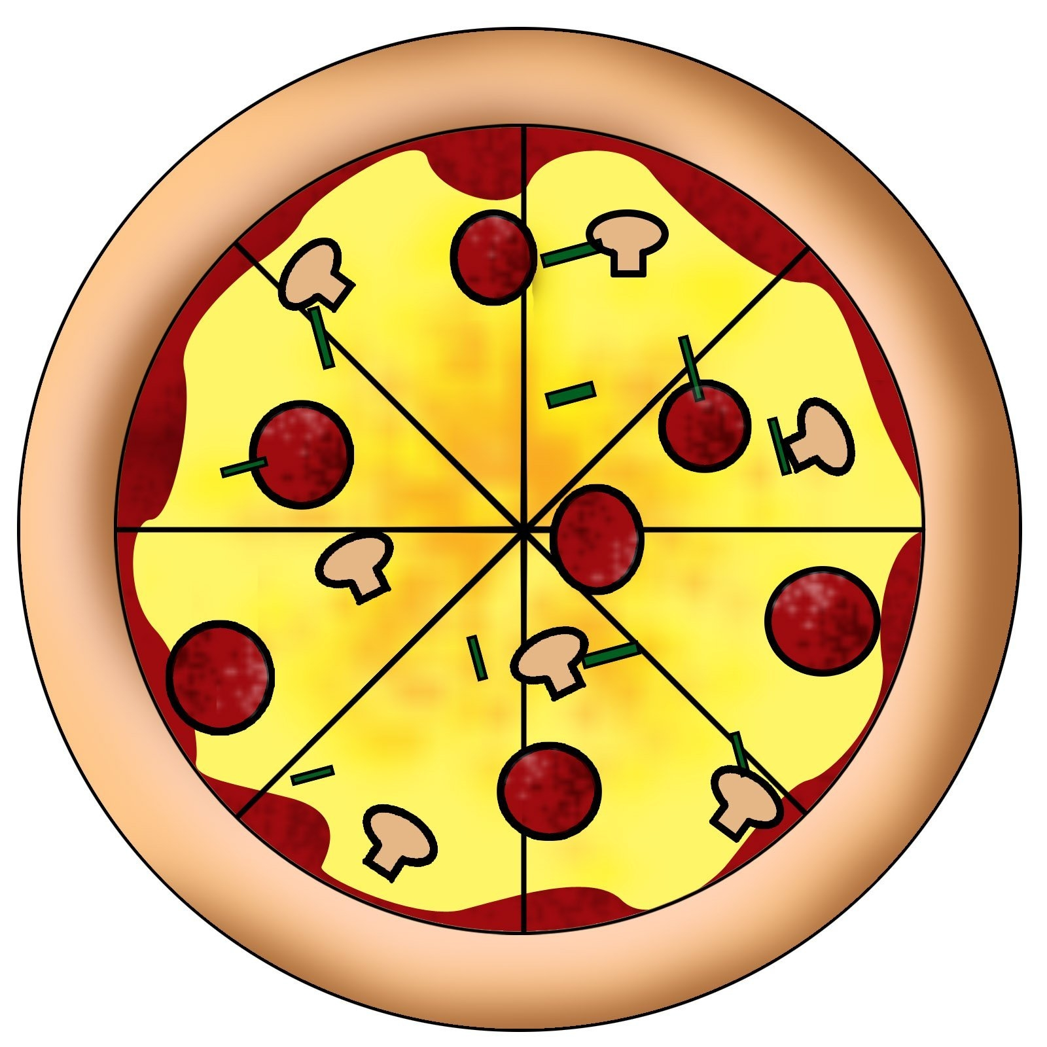
Ending the lesson  (5 min)  Home task |  | Self-assessment Children write their opinions. What grade do they think he received?      Page 96 ex.2 and card  